

Land Information Ontario (LIO) Warehouse

Data Class Name: Indian Reserve

Documentation

Produced by: Information Access and Information Management Policy Unit

Ministry of Natural Resources and Forestry

Date: July 27, 2015

**Purpose**

This document provides additional information to support the use of geospatial data. The Physical Model Diagram provides a visual representation of the relationships in the data class. The Data Change History lists all the modelling and access changes that have occurred during the lifecycle of the data class. A data description identifying table and field names is available upon request.

**Need Assistance?**

Please contact LIO Support at [lio@ontario.ca](mailto:lio@ontario.ca) or 705-755-1878 if you require help.

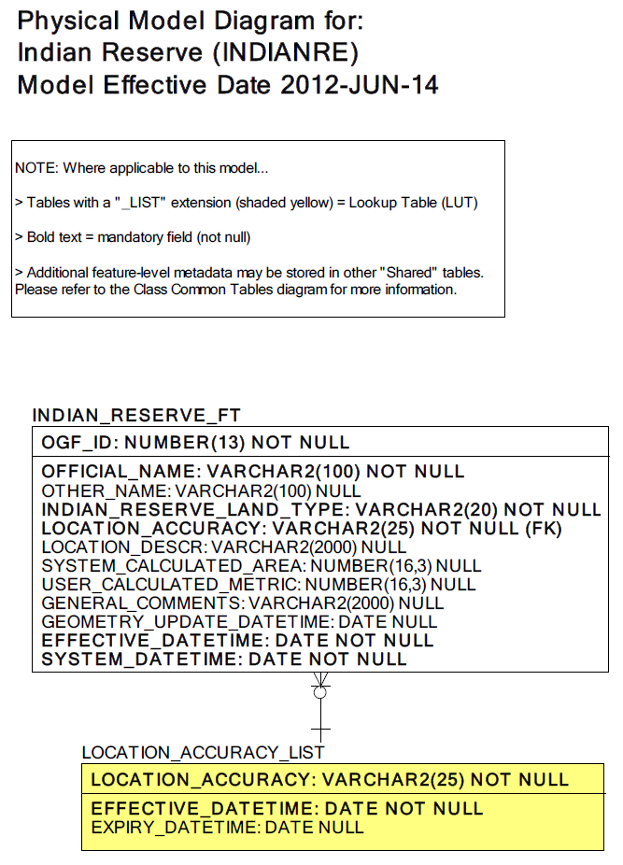  
Data Class Change History

Data Class Name: Indian Reserve

Data Class Short Name: INDIANRE

| Date  YYYY-MM-DD | Details of Change |
| --- | --- |
| **2008** | GUT Description change:  Received new description from BDI |
| **2008** | Data Class Description Change:  Received new description from BDI |
| **2006** | NEW Data Class |

**Data Description**  
Please refer to the metadata record for the data description.